Select statement example:

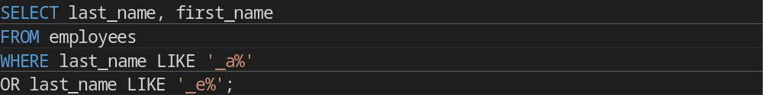

SELECT last_name, first_name
FROM employees
WHERE last_name LIKE '_a%'
OR last_name LIKE '_e%';

